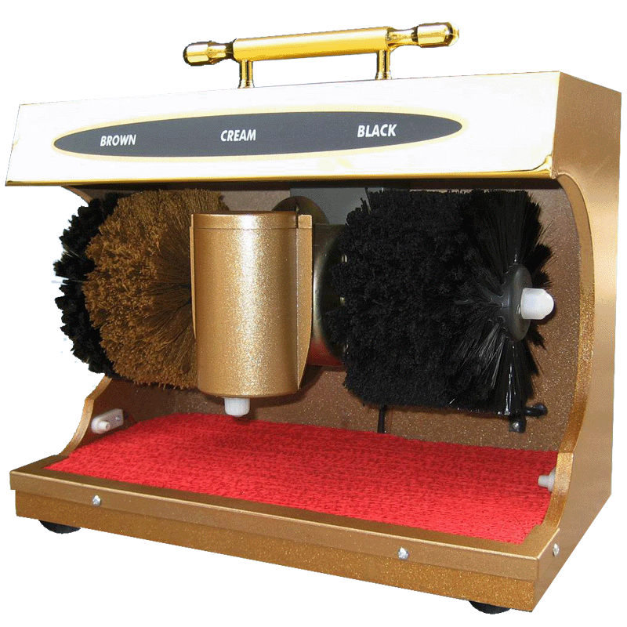

Buff and shine your shoes professionally, but without the high cost and wait. Suitable for all types of shoes, quickly and easily. This electric shoe shiner is a practical machine for the home,in hotel, home ,office ,supermarket and many other places . The machine is started and stopped by means of automatic pulse type sensor. With 2 other soft brushes, one to apply polish and other to complete shine (or for different color shoes!) will make your shoes like new.

:

Model : ASP G5

Voltage: AC220V/50HZ

Power: 45w

Motor speed:900r/m

Noise factor: ≤50dB

Volume for grease cup : 100ml

SHOE SHINE MC ASP G5